REVISION HISTORY
REV | ECO
SW Programming Requirements (SPR)
CONTRACT NO. |  |  |  |  |  |  | Elbit Systems Ltd
ACTN |  | NAME |  | SIGNATURE | DATE | Advanced Technology Center
 |  |  |  |  |  | P.O.B. 539, Haifa 31053, Israel
PREP |  | T.B.D |  |  | 4/2018 | Title :
SEPG Manager |  | T.B.D |  |  |  | SW Programming Requirements (PR)
SW Manager
SQA |  |  |  |  |  | SIZE |  | CAGE CODE |  | NO.
 |  |  |  |  |  | A |  | 2288A
 |  |  |  |  |  | SCALE NONE |  |  |  |  |  |  | SHEET 1 of 12

THIS DOCUMENT AND ITS CONTENT BELONGS TO ELBIT SYSTEMS LTD. AND CONTAINS ELBIT PROPRIETARY INFORMATION.
THIS DOCUMENT AND THE INFORMATION CONTAINED IN IT OR ANY PART THEREOF MAY NOT BE COPIED IN ANY WAY AND MAY NOT BE USED IN WHOLE OR PARTS THEREOF IN ANY WAY WITHOUT THE WRITTEN CONSENT OF ELBIT SYSTEMS LTD.
© 2015 by Elbit Systems Ltd.

SW Programming Requirements

for the

DLS Project
Bluetooth application

CDRL SEQUENCE NO. T.B.D

Prepared for:
ELBIT SYSTEMS LTD.

Prepared by:
COMM-IT, 20 Hamagshimim St.
Petach Tikva 49348, ISRAEL

TABLE OF CONTENTS

1. Scope 4
2. Programming files Table 4
3. Programming Equipment and Set-Up 4
4. Programming Instruction 5
4.1. Program the DLS Bluetooth APK via ADB tool 5
4.2. Remove DLS Bluetooth APK from target via ADB tool 5
5. Appendixes 6
5.1. APPENDIX A – Installation of ADB tool at Host system 6
5.1.1. Download the ADB tools 6
5.1.2. Use ADB tool 6
5.1.3. Run ADB tools from tool directory: 6
5.1.4. Add ADB to “system path” variables 7
5.2. APPENDIX B: Enable “USB debugging” at Android target device 9
5.3. APPENDIX C: Check if the target is rooted and connected well 9

Scope
This SW PR describes the necessary files, means and procedures required to program the DLS system with the Bluetooth application file that mentioned below.

Programming files Table

TABLE I.  LOADING SEQUENCE |  |  |  |  | TABLE II.  VDD REFERENCE
NOTE: The SEQ No. is the order of loading the programs!
SEQ | Programming Tool | FILE NAME | CHECKSUM |  | VDD Number
1 | Android debug bridge (ADB) | DLS_BT_1_4.apk | N/A |  | T.B.D

Programming Equipment and Set-Up

In order to program the APK (Android application package) to the system target you need to use Android data cable (Micro USB cable).
Then you must to install the followings:
- ADB tool at your host system (Explanation of tool installation provided at appendix A).
- Enable “USB debugging” at your Android target (The Android target must be rooted in order for programing the device).

Programming Instruction

Before programing the device please check that you accomplish appendix A + B + C and the target device in connected and configured well.

Program the DLS Bluetooth APK via ADB tool

adb install /path/to/DLS_BT_BLE_1_4.apk

Remove DLS Bluetooth APK from target via ADB tool
adb uninstall DLS_BT_BLE_1_4.apk

Appendixes

APPENDIX A – Installation of ADB tool at Host system
The following part describe how to install ADB tools at Windows host system

Download the ADB tools
Please go to ADB manufacture site in order to download latest ADB shell windows tool.

The programing procedure tested with the following ADB version:
a. version 1.0.32
b. Revision eac51f2bb6a8-android

Use ADB tool
There are two options to use the ADB tools: from command line that run at the ADB tools directory or by added ADB tools to Windows host “system path” (describe at 5.3).

Run ADB tools from tool directory:
Go to ADB install folder then drag the file “adb.exe” to command line (CMD) window; this will copy the path of the ADB tool to CMD. Then insert the ADB commands.

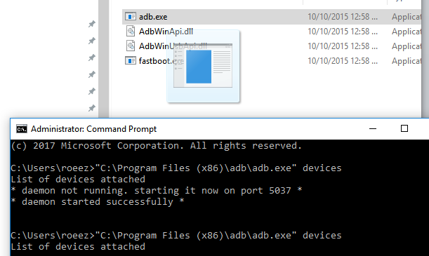

Add ADB to “system path” variables
- Click Windows button on the keyboard
- Search for “View Advanced system settings”
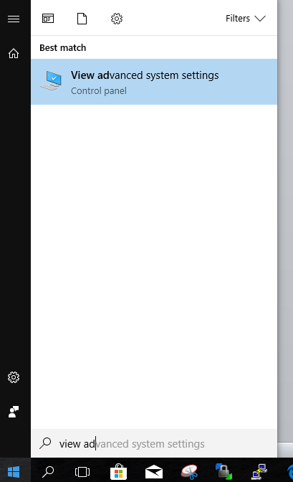

- On “Advance” tab click on “Environment Variables” button.
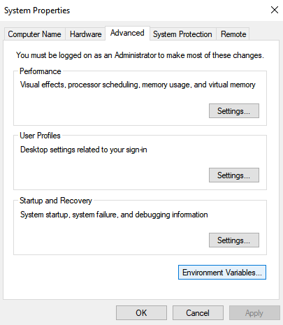

- In the “System Variables” box, look for a variable called “Path”. Select that and click on the “Edit” button:
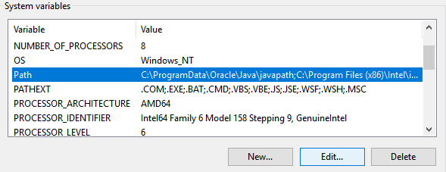

- Add the location of the ADB tool synonym.

At Windows 10:

Click at “new” button (on the left side bar) then add the path of the ADB tool, at finish click “OK” button:

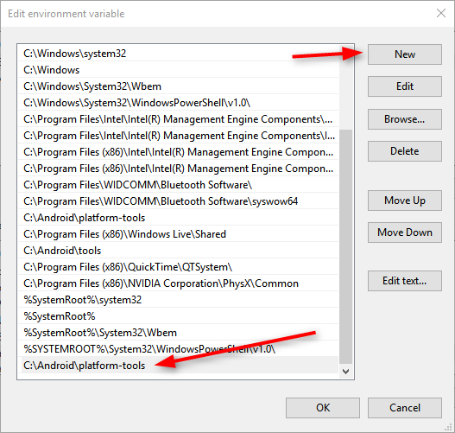

At Windows 7 / 8:
At this OS the variables present as a long string and each variable value separate with semicolon.
Please add the ADB tool to the end of the string with the beginning of semicolon (for example: [;C:\Android\platform-tools] then click OK button to save changes.

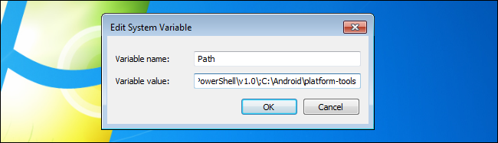

APPENDIX B: Enable “USB debugging” at Android target device

In order to work with ADB shell at the Android target the device you must enable the USB debugging options via the following procedure:
- Go to “System Settings”.
- Go to “Developer options”.
- Check the “USB debugging” options.

APPENDIX C: Check if the target is rooted and connected well

In order to check if the device is ready to program with ADB tool, you can insert the command “adb devices”
In case that the devices has no connection of configurations difficulties the following will present:

